**Is India becoming a new Silicon Valley or just a Puppet?**

How is Covid-19 affecting various markets and manufacturers? What is the loss or success statistics with the pandemic, and how is everyone coping up with it? Who might come up be a winner after all the competitions? Here is the answer to all the queries. Hold your breath and go through this all!

The USA, which was known for most of the success patterns and various Silicon Valley products and applications, had faced a disruption with many deaths that have occurred due to the pandemic. And, when it comes to China, because of the tactics it has been opting for various enhancements and conquering the world, many of the countries are trying to shift from China and have been setting up their offices and manufacturing units in other parts of the world.

However, amidst the COVID-19 pandemic when most of the countries who were the Tech Giants for the whole of the world have lost their success trends, India on the other hand, has seen a surge in its market. Chanel, Hermes, Victoria’s Secret, Airbnb, all of these globally recognized brands have faced enormous losses and have either discontinued or went to the edge of bankruptcy. But, Indian Jio applications, delivery apps, and others have experienced success and growth in the user-base.

India has been known as the Golden Bird for many decades and now with this pandemic, the investments that are offered to India for various advancements and setups can be a booster for the Indian market!

Silicon Valley’s top venture capitalist and entrepreneur, Mr. M. R. Rangaswami stated in one of his interviews for PTI that the upcoming 10 years are going to be a golden moment for India, and India can come up just like the previous Golden Bird with the surge in various sectors like technological, Pharmaceutical, E-Commerce, and even manufacturing.

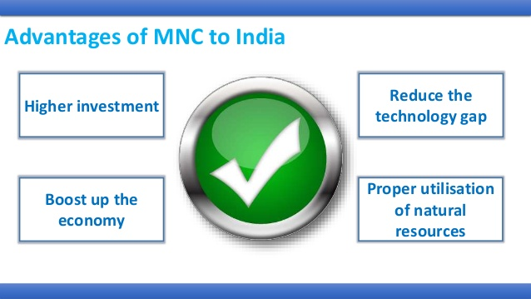

But how is this going to happen? How is India going to receive the capital for the productions and the developments?

So, coming up like a support system, the biggest Tech Giants have decided to provide various investments and capital sum for the developments. Like, Sundar Pichai promised an investment of USD 10 billion from Google, Facebook promised for 5.7 billion USD, Walmart 1.2 billion USD, and Foxconn for 1 billion USD. With these, there’s a huge bank amount generation for the Indian government to gain global success. Apple has also decided to shift its manufacturing units from China to India.

With these investments and setups, India will have greater employment opportunities, and opportunities to enhance the Research and Development sector and come up with mind-boosting innovations. But, how will Indians strategize these opportunities? Would they be able to be the pro managers?

Various countries are also promoting Ban-China or anti-China campaign that is helping India to increase its manufacturing market with various supports. Not only this, but even India is using the ‘Made in India’ campaign to wipe away the Chinese applications. Around 59 of them are banned and this came out to be a market booster for the technological and software sector of the native Unicorns. Various Indian substitutes have experienced a market boost with the same.

India is just like a center of attraction for lots of tech giants including Amazon and various other MNCs. When Amazon is continuing to invest in India, most of the other private firms are MNCs are looking to make their way into the country with investments or shares.

After all these efforts, is India becoming a hot-spot for attracting Silicon Valley investors?

In the COVID-19, China has experienced a fall from everyone's eyes because of the various bad tactics that have been opted like for the vanishing of the Uyghur Muslims with genocide and sterilizations, and also the Galwan clash where Chinese troops attacked Indians killing many of them. Everything has been added up to make all the other global Giants oppose China including the US too.

But the question is how the Indian government is going to take this opportunity and transform?

After the pandemic is over and everyone tries to regain their positions, it is to be seen how India manages to maintain the earned development and success pattern, or it would just drown away with everyone else gaining their powers.

Various options are available like it could be a possibility that India can be a golden bird, but it can also be a puppet for various MNCs and also for the US and China!